Scratch Lesson 1:

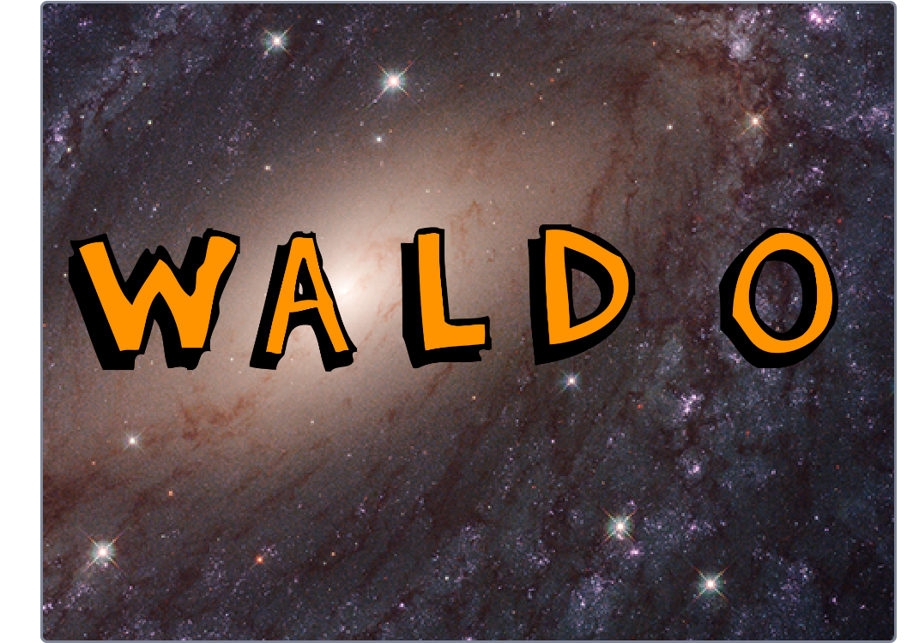

Create Name and have it fly apart when started.
Play Sound
change background
Show animation.

1.1 Choose backdrop.
1.2 Click on Backdrops choose a second one.
1.3 Show drawing tools.
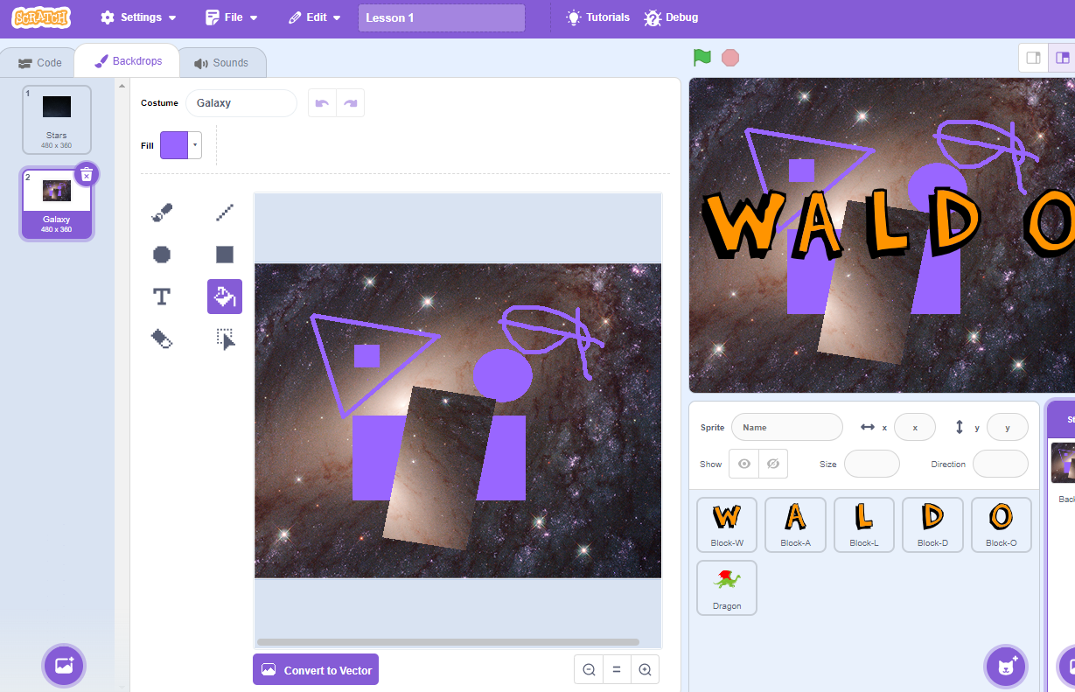

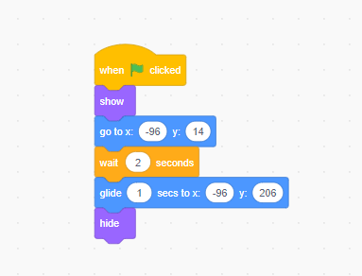
Add Letters.

Add this to each letter.

Fist x and y = correct positions

Second = reset positions.

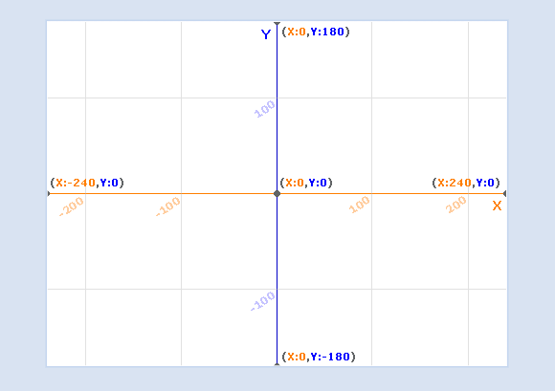

On first letter add.

Show sound bar.

Show xy backdrop

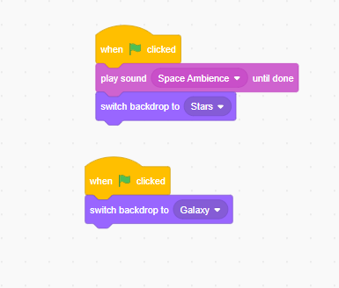

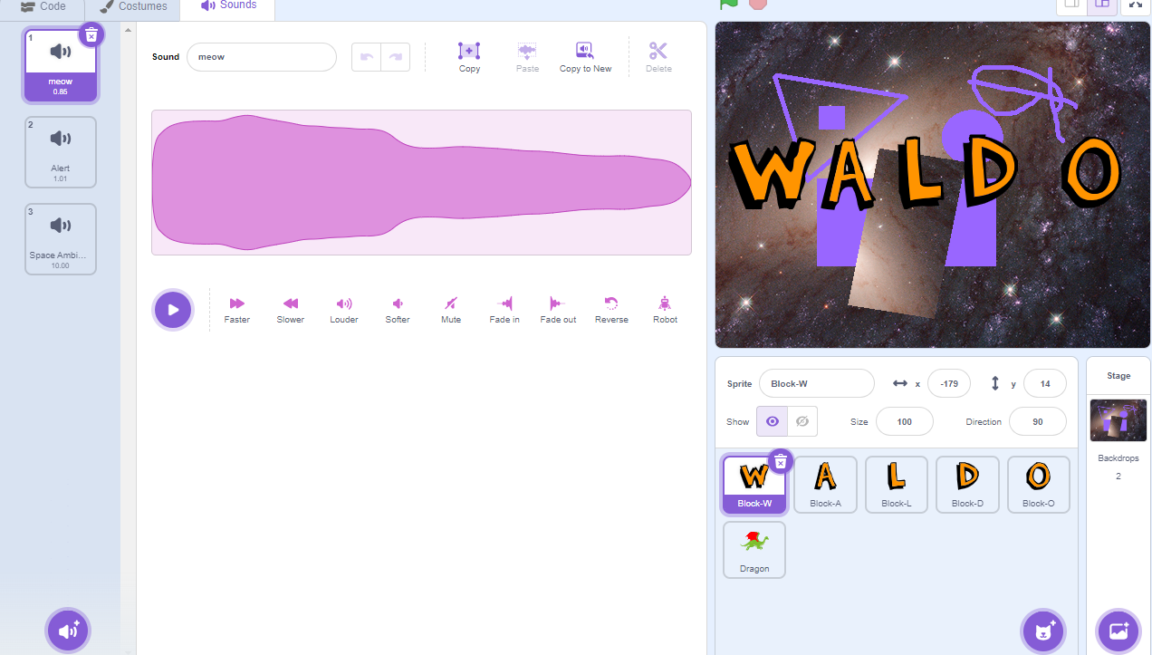

Switch to other backdrop

get sprite

Show costumes tab.
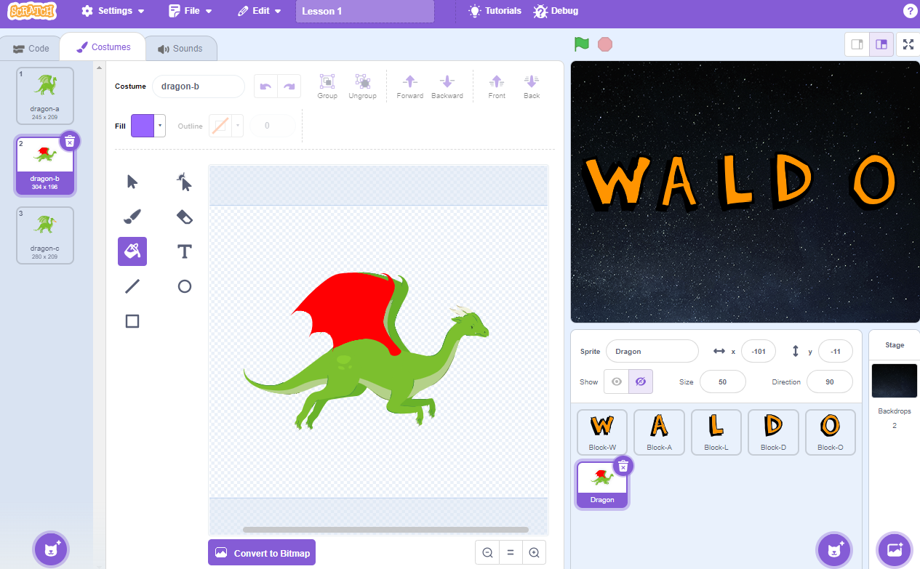
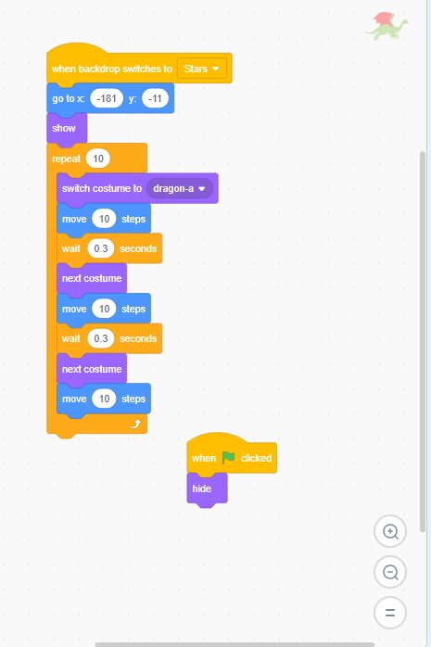
Add this code.

